**Genome reconstructions of metabolism of *Plasmodium* RBC and liver stages**

Anush Chiappino-Pepe 1,2,3, Vikash Pandey 4,5, Oliver Billker 4,5

1 Department of Genetics, Harvard Medical School, Boston, MA, 02115, USA

2 Wyss Institute for Biologically Inspired Engineering, Boston, MA, 02115, USA

3 Department of Chemical Engineering, Massachusetts Institute of Technology, Cambridge, MA, 02139, USA

4 Department of Molecular Biology, Umeå University, Umeå, 90187, Sweden.

5 The Laboratory for Molecular Infection Medicine Sweden, Umeå, 90187, Sweden.

**Abstract**

Genome scale metabolic models (GEMs) offer a powerful means of integrating genome and biochemical information on an organism to make testable predictions of metabolic functions at different conditions and to systematically predict essential genes that may be targeted by drugs. This review describes how *Plasmodium* GEMs have become increasingly more accurate through the integration of omics and experimental genetic data. We also discuss how GEMs contribute to our increasing understanding of how *Plasmodium* metabolism is reprogrammed between life cycle stages.

**Keywords**

*Plasmodium,* Malaria, Metabolism, Antimalarial drug development, Liver stage, Erythrocytic stage, Phenomapping, Genome-scale metabolic models, Aminosugar metabolism

**Introduction**

Genome-scale metabolic models (GEMs) describe the metabolism of a cell mathematically. They include all associations between metabolites, reactions, enzymes, and genes [1]. The assembly of metabolic information in a single framework allows biochemical interactions between cellular components to be simulated at a systems-level and enables a holistic understanding of complex phenotypes. GEMs of pathogens are used to investigate metabolic processes underlying host-pathogen interactions [2], cellular nutritional requirements [3–5], antimicrobial resistance [6], and metabolic reactions that due to their essential nature may become targets for drugs [7].

GEMs are highly curated resources which are built in several steps [8,9] (Figure 1). First, a draft GEM is constructed by gathering all genes with metabolic annotations and their associated reactions that can be obtained from the literature, databases, or homology searches. Since genome annotations are incomplete, draft GEMs have gaps that disrupt the connectivity between compounds. Gaps are identified by defining all metabolic tasks that specify the production of biomass building blocks or growth by-products from a set of substrates. The presence of missing enzymes and reactions can then be hypothesised. This gap-filling process produces a well connected metabolic network, on which physiological constraints are imposed to obtain a curated GEM. Constraints may be organism-specific or context-specific [9]. Organism-specific information is part of every generic GEM and includes data or assumptions on enzyme localization, intracellular metabolite transportability, and enzymatic irreversibility. Context-specific GEMs include further constraints, for instance from data on media composition, reaction directionality allowed by metabolite concentrations and thermodynamics, or information on whether an enzyme or transporter encoded in the genome is actually present, which may be inferred from gene or protein expression data. The set of equations that constitute a GEM is then used in a mathematical approach called flux balance analysis [10], to determine computationally the steady-state metabolic flux through each reaction when a given set of constraints are applied. From this, cellular phenotypes such as growth are predicted, for instance by defining growth as a state where all biological building blocks are produced.

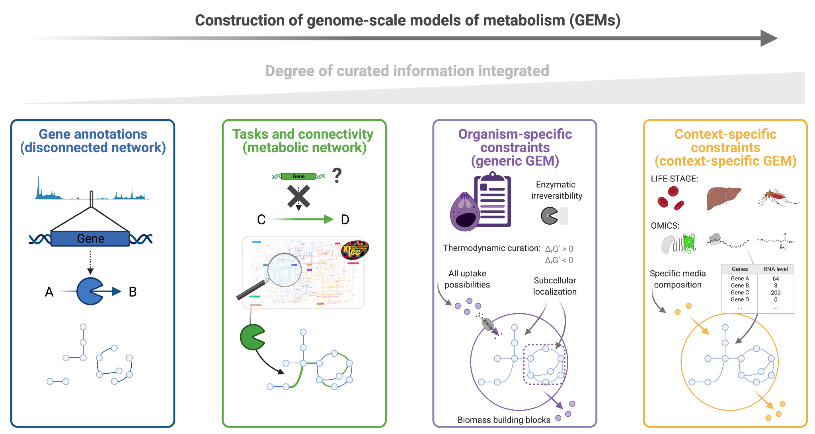

**Figure 1. Conceptual framework constructing and curating GEMs**. First, GEMs include gene annotations linking genes, enzymes and reactions. This renders a disconnected metabolic network. Second, through the definition of metabolic tasks, the metabolic network gets connected with hypothetical reactions. Third, a GEM is generated by defining constraints. We define organism-specific constraints (like enzymatic irreversibility or thermodynamic curation) to generate generic GEMs and context-specific constraints (like a specific media composition or omics data) to render context-specific GEMs.

When constructing GEMs, the expectation is usually not to obtain a perfect reflection of reality, but to integrate all available genome and biochemical information on an organism, including various types of omics data, to make testable predictions of metabolic functions at different conditions. The latest generation of *Plasmodium* GEMs [11] are *in silico* organisms in which gene expression patterns can be modified, and the environmental availability or uptake capability for metabolites can be altered to reflect the parasite’s progression through its life cycle. They can be used to predict the impact of targeting enzymes genetically or chemically, or to identify environmental factors that limit parasite growth in different hosts. Importantly, GEMs make explicit all our knowledge gaps and error prone assumptions regarding *Plasmodium* biochemistry and physiology, like gene functions, protein localizations, transport capabilities and nutrient availabilities. Testing available GEMs against the rich sets of phenotype data that have now begun to emerge from genome scale knockout studies in malaria parasites [11–13] marks the beginning of an iterative process to increase our understanding of *Plasmodium* cell function and guide the design of effective drug treatments.

**Genome scale metabolic reconstructions in *Plasmodium.***

Sequencing of the *P. falciparum* genome [14] provided the basis for the mathematical investigation of metabolism in malaria parasites. Initially, relatively simple chokepoint analyses in automatically constructed networks were used to predict enzymes with unique metabolic tasks as potential drug targets [15,16]. *P. falciparum* blood stage GEMs have since become increasingly more complex, manually curated, and realistic. More genes and reactions have been incorporated, reflecting our increasing knowledge of parasite metabolism, and inclusion of metabolite consumption and production fluxes has enabled flux balance analysis (Table 1). The iPfa model for *P. falciparum* predicts essential genes in the presence of thermodynamic constraints, i.e. considering the direction in which a reaction can operate given experimentally determined concentrations of metabolites [4].

In an important move towards stage-specific models, the most recent GEMs have been constrained with stage-specific data on transcript abundance. Five models for *P. falciparum* trophozoites, schizonts, early gametocytes, late gametocytes and ookinetes were constructed with a view to predict drug targets that are essential at different blood stages, irrespective of whether these are actively proliferating or not [7]. These models therefore additionally consider stage differences in growth, glucose uptake and lactate secretion between proliferative asexual and early sexual stages and non-proliferative late sexual stages. In the rodent-specific model parasite *P. berghei*, stage-specific GEMs are available for the asexual blood stage and the pre-erythrocytic liver stages. Both consider thermodynamic constraints in addition to transcript abundance [11,17].

In *P. berghei*, barcoded gene targeting vectors from the *Plasmo*GEM project [18] now allow knock-out phenotypes to be measured at genome scale [11,12]. Similarly, transposon mutagenesis has provided global data on gene essentiality in *P. falciparum* [13]. Reconciling experimental phenotypes with models at such scale necessitated a new computational pipeline called PhenoMapping [9,11], with which it was possible to iteratively curate a *P. berghei* GEM [11] in the light of experimental data to predict metabolic bottlenecks and predict essential drug targets. The same PhenoMapping pipeline served to curate a GEM of *Toxoplasma gondii* [(5)](https://www.zotero.org/google-docs/?broken=T9hh75) based on CRISPR phenotypes, thereby demonstrating its broad applicability to interpret phenotypes.

**Table 1.** Metabolic networks and genome-scale models for *Plasmodium* metabolism.

|  |  |  |  |  |  |
| --- | --- | --- | --- | --- | --- |
| **Year** | **Name and reference** | **Organism** | **Life-stage** | **Computational analysis** | **Source for genes and enzymes** |
| 2004 | Yeh et al. [16] | P. falciparum 3D7 | Blood stage | Chokepoint enzymes | PlasmoDB (GeneDB), PlasmoCyc |
| 2009 | Fatumo et al. [15] | P. falciparum 3D7 | Blood stage | Chokepoint enzymes | PlasmoCyc, MPMP |
| 2010 | iTH366  Plata et al. [19] | P. falciparum 3D7 | Blood stage | FBA | PlasmoDB (GeneDB), MPMP, KEGG, PlasmoCyc |
| 2010 | PlasmoNet Huthmacher et al. [20] | P. falciparum 3D7 | Blood stage | FBA | MPMP, KEGG, BioCyc, Reactome, Transport Classification Database |
| 2012 | PlasmoNet2 Bazzani et al. [21] | P. falciparum 3D7 | Liver stage | FBA | PlasmoNet |
| 2017 | iPfa [4] | P. falciparum 3D7 | Generic, Blood stage | FBA, TFA, metabolomics, substrate channeling, in silico minimal media | PlasmoDB (GeneDB), MPMP, KEGG |
| 2017 | iPfal17  Carey et al. [22] | P. falciparum 3D7 | Blood stage | FBA | iTH366 |
| 2018 | iAMPf480 Abdel-Haleem et al. [7] | P. falciparum 3D7 | Blood stage | FBA, transcriptomics | PlasmoDB (GeneDB), MPMP |
| 2018 | Pber Abdel-Haleem et al. [7] | P. berghei | Blood stage | FBA, transcriptomics | iAMPf480, PlasmoDB (GeneDB), MPMP, KEGG |
| 2018 | Pviv Abdel-Haleem et al. [7] | P. vivax | Blood stage | FBA | iAMPf480, PlasmoDB (GeneDB), MPMP, KEGG |
| 2018 | Pkno Abdel-Haleem et al. [7] | P. knowlesi | Blood stage | FBA | iAMPf480, PlasmoDB (GeneDB), MPMP, KEGG |
| 2018 | Pcyn  Abdel-Haleem et al. [7] | P. cynomolgi | Blood stage | FBA | iAMPf480, PlasmoDB (GeneDB), MPMP, KEGG |
| 2019 | iPfal19  Carey et al. [23] | P. falciparum 3D7, other Apicomplexan parasites | Blood stage, others | FBA | iPfal17, BiGG |
| 2019 | iPbe  Stanway et al. [11] | P. berghei ANKA | Generic, Liver stage, Blood stage | FBA, TFA, metabolomics, transcriptomics, PhenoMapping | iPfa, PlasmoDB (GeneDB), MPMP, KEGG, ATLAS of Biochemistry |

**Insights into metabolism of the asexual blood stages.**

The asexual blood stage is responsible for the pathogenesis associated with malaria. It is also the primary target for all commercially available antimalarial drugs, and all validated drug targets are essential enzymes or transporters. The replicating and therefore metabolically very active intraerythrocytic parasites obtain amino acids by digesting host hemoglobin, but they additionally rely on increasing the permeability of the erythrocyte membrane to low-molecular-weight solutes to access for instance sugars, amino acids, purines and vitamins from the blood plasma [24]. A systematic comparison of GEMs for five rodent and primate species of *Plasmodium* revealed a high degree of conservation, but also some notable differences in thiamine, choline and pantothenate metabolism that are at least in part consistent with available knockout phenotypes [7]. None of the blood stage GEMs have so far been examined experimentally for their ability to make genuinely new predictions.

Initial blood stage GEMs focussed on predicting essential genes and reactions, but more recent models also harness the power of GEMs to investigate the precise mechanisms underpinning phenotypes. For example, the thermodynamics-based flux balance analysis (TFA) in iPfa predicted as essential the synthesis of amino sugars, which was initially included as a hypothetical reaction when metabolomics data was integrated into iPfa (Figure 1, Step 2) [4]. TFA suggested a number of bottleneck metabolite concentrations as reason for the essentiality, including UDP-N-acetylglucosamine. An independent study later discovered the enzyme glucosamine-6-phosphate N-acetyltransferase and confirmed its predicted essentiality in *P. falciparum* [25]. The TFA analysis of iPfa also suggested substrate channeling in the pyrimidine biosynthesis and Kennedy pathways to allow metabolic flux toward the production of important biomass building blocks (purines and phosphatidylethanolamine) in iPfa. A separate *in silico* analysis of minimal media using iPfa predicted substrates that can substitute for each other to support parasite growth. Investigation of these redundant substrates revealed backbone moieties that *Plasmodium* needs to scavenge from the host cell to survive and whose uptake could be targeted with drugs to prevent the proliferation of the parasites. The combination of the *in silico* minimal media and PhenoMapping analysis then predicted which substrates could account for the essentiality of a set of genes in the blood and liver stages of *Plasmodium* if insufficiently accessible from the medium [11,26]*,* highlighting how culture conditions or nutritional state of a host may affect the outcome of genetic experiments or drug screens.

Having been optimised iteratively with genome scale experimental phenotypes, the iPbe-blood model [9,11] is characterised by a high level of accuracy approaching that obtained with the best *E. coli* models [11,26]. The accuracy of GEMs in a divergent eukaryote like *Plasmodium* remains limited, however, by our incomplete understanding of its non-canonical biology. This is highlighted by a recent study in which *P. falciparum* infected erythrocytes were exposed to a broad range of isotope-labelled carbon sources [27]. Metabolomic analysis revealed 89 unpredicted metabolites, 92 new reactions and led to the validation of four previously uncharacterised enzymes. Data from this study, which also highlights the activity of metabolite repair pathways in *Plasmodium*, are important to further curate and constrain available *Plasmodium* GEMs.

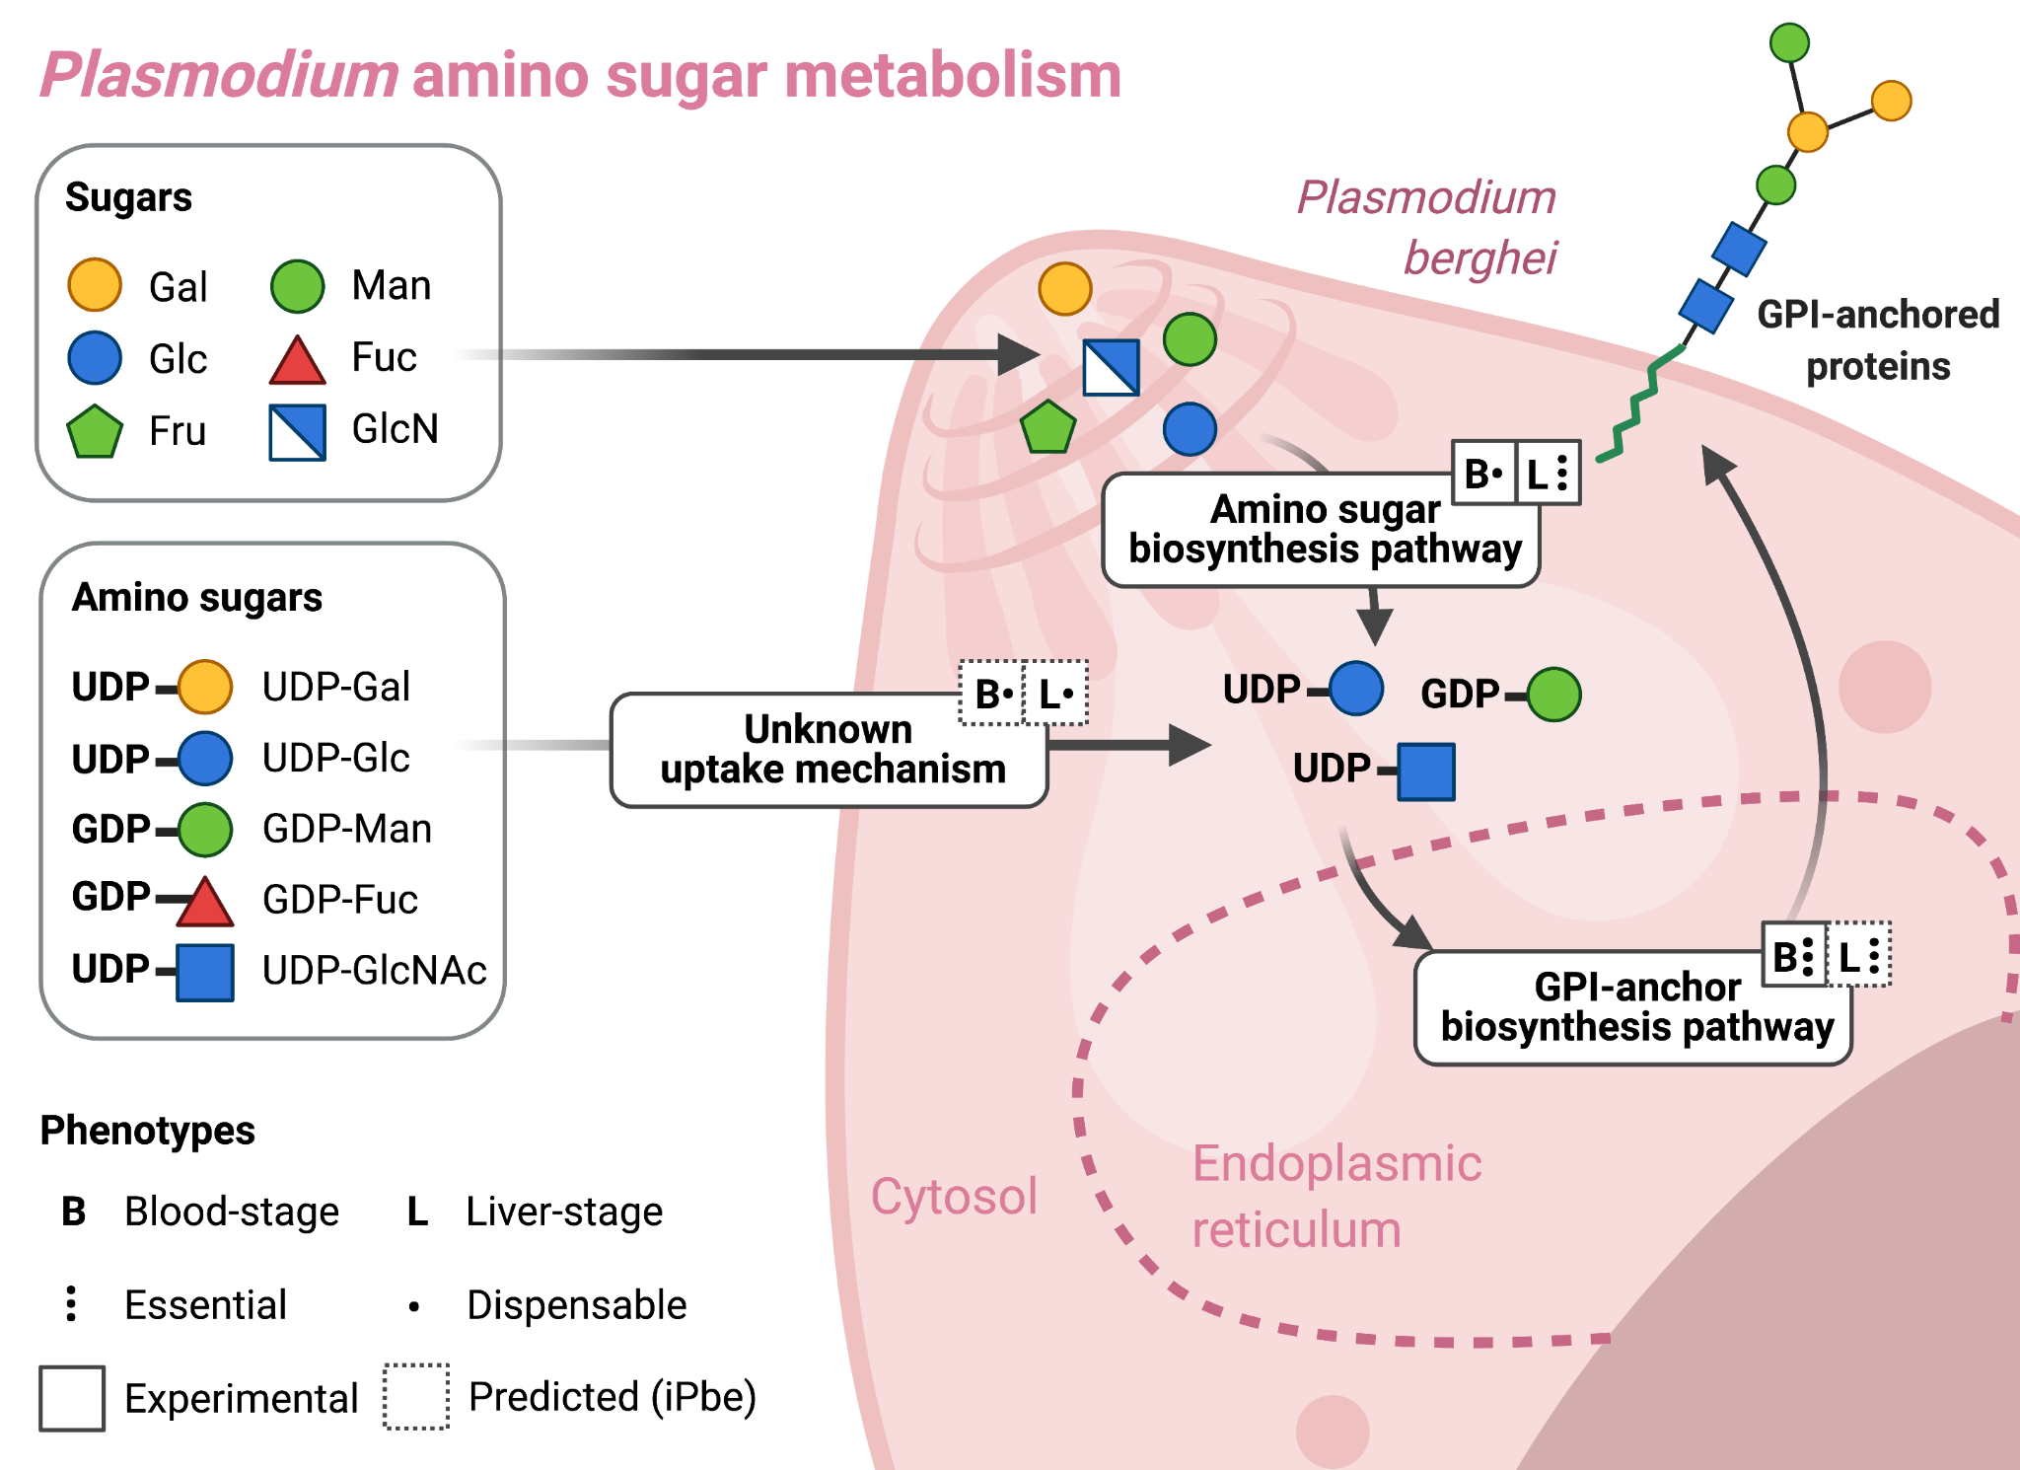

Figure 2. Amino sugar metabolism in stage specific iPbe GEMs of *P. berghei* which were curated with experimental phenotypes from *Plasmo*GEM blood- (B) and liver- (L) stage genetic screens using PhenoMapping. Amino sugar synthesis in the *Plasmodium* cytosol is dispensable (one dot) at the blood stages, but amino sugars are needed to produce the essential (three dots) GPI-anchor proteins in the endoplasmic reticulum. To predict these phenotypes with iPbe, PhenoMapping’s top hypothesis is that amino sugars are scavenged. This hypothesis holds for the liver phenotypes, where the availability of amino sugars might not be large enough from the host hepatocyte cell to sustain the rapid liver-stage *Plasmodium* growth. Hence, in the liver-stages the synthesis of some amino sugars becomes essential.

**Insights into liver stage metabolism.**

Malaria parasites infect their human hosts through the bite of infected *Anopheles* mosquitoes, which inject motile sporozoites that invade hepatocytes. Over the course of a few days the parasites grow dramatically in the liver, until thousands of daughter merozoites are released into the bloodstream, where they invade red blood cells and initiate the erythrocytic phase of the infection, which causes disease. Most antimalarials do not kill the liver stages, but such drugs would be valuable to prevent clinical symptoms, and especially if they could also clear dormant liver stages of the *Plasmodium vivax* parasite, which can re-activate to establish blood stage infection many years after the original mosquito bite [28]. Parenchymal liver cells provide a particularly nutrient rich environment for the rapid expansion of the parasite, whose liver stage has long been known to rely on unique metabolic capabilities for the biosynthesis of heme and fatty acids [27,29,30].

A global knock-out study in *P. berghei* has provided the first opportunity to investigate the metabolic vulnerability of the liver stage systematically and has provided experimental evidence for a broad reprogramming of parasite metabolism to achieve rapid growth in the liver. Stanway *et al.* [11] studied >1300 mutants in genes that are non-essential in the blood stage and found metabolic functions are enriched among liver stage essential genes. Mapping the screen results into the iPbe-liver model predicts at least seven metabolic subsystems as essential for the liver stage when compared with the asexual blood stage. The study confirmed that type-II fatty acid synthesis (FASII) is essential at the liver stage, probably to meet the increased demand of the rapidly growing parasite for membrane lipids, although the GEM offers other possible explanations. Stanway et al. [11] additionally identified fatty acid elongation (FAE) in the endoplasmic reticulum, tricarboxylic acid (TCA), heme, lipoate, and shikimate metabolism, as well as steps in amino sugar biosynthesis as specifically essential in the liver.

Stanway et al. [11] used a GEM constrained with liver-specific metabolomic and gene expression data, which they then optimised iteratively by incorporating genetic screen data, and by validating predictions experimentally with individual cloned mutants. Using a GEM provided a means of incorporating blood-stage essential pathways in the analysis, whose genes could not be studied directly at the liver stage. The iterative optimization by PhenoMapping provided a means of flagging up and examining potential experimental errors, which are not uncommon in screen data, and allowed gaps in the experimental data to be closed by imputation. Above all, the approach generated hypotheses in a manner that is both rigorous and unbiased, in that it considers all possible modifications to the model that would make it consistent with experimental observations.

An example of the hypothesis generating power of GEMs is again provided by the amino sugar pathway (Figure 2). *P. berghei* parasites possess canonical enzymes to activate sugars for making glycoconjugates. Among a network of reactions, only the biosynthesis of N-acetyl-glucosamine emerged as essential for liver stage parasite development in *P. berghei*. Mapping of experimental phenotypes with iPbe liver and iPbe blood makes some important predictions, namely that parasites can take up most nucleotide sugars from the hepatocyte or erythrocyte, respectively, but that at the liver stage UDP-N-acetyl-D-glucosamine uptake becomes limiting [11]. This is in contrast with data from *P. falciparum*, where enzymes for UDP-N-acetyl-D-glucosamine biosynthesis resist disruption at the blood stage *in vitro* [25,31]. Whether this is due to differences in uptake capabilities between parasite species or whether culture medium provides *P. falciparum* with insufficient quantities of aminosugars remains to be investigated.

Transporters for nucleotide uptake from the host have not been described from any parasite, but iPbe predicts gene(s) encoding such transport functions to become essential when the corresponding pathway for amino sugar biosynthesis is additionally disrupted. A knock out screen of transporter genes for synthetic lethality with sugar activating enzymes is now technically feasible in *P. berghei* [32] and could lead to the experimental identification of such genes. What becomes clear from these considerations is that the computational prediction of synthetic lethality in GEMs, followed by experimental investigation, provides a promising means of identifying gene functions and closing knowledge gaps systematically.

**Outlook**

* The construction of GEMs in *Plasmodium* has so far concentrated largely on the vertebrate stages, which are the targets of current antimalarial drugs. However, understanding how parasite metabolism adapts to the mosquito environment is also important. The nutritional state of the vector affects dormancy and developmental rate of the oocyst attached to the mosquitoes midgut [33,34]. Modelling these metabolic interactions between vector and parasite is therefore important to understand the reproductive rate of malaria under different environmental conditions. It will require better data on the physiological concentration range of metabolites in mosquito hemolymph. For *Anopheles* mosquitoes no GEMs are currently available, and we know of no attempts to computationally model pathogen host metabolic interactions at genome scale.
* Life cycle stages are somewhat arbitrarily defined, and metabolic reprogramming occurs continuously, as do changes in transcript abundance. A transcriptional single cell atlas of malaria parasite development is now available [35], as are tools to analyse cellular metabolic fluxes of individual cells [36,37]. Such analysis would, however, need to consider that it is not the transcripts but proteins that define the metabolic capability of a cell, and that posttranscriptional regulation of gene expression is common in *Plasmodium*. It would be preferable, therefore, to constrain *Plasmodium* GEMs with proteome data where available.
* Optimising GEMs through phenotype data from *P. berghei* genetic screens using PhenoMapping proved useful to rationalise experimental data and impute experimental gaps when predicting essential genes. The global essentiality data from *P. falciparum* asexual blood stages [13] have to our knowledge not yet been put to use in this way.
* Chemical screens have identified compounds that inhibit the liver stage selectively or preferentially over the asexual blood stage [38,39]. Their modes of action need to be identified for further optimisation. The list of liver stage specific essential pathways predicted by iPbe-liver [11] provides good starting points to identify the physiological targets needed to optimise some of these compounds. More targeted genetic screens of metabolic mutants may also be used to identify the tightest developmental block at the liver stage for use in a live attenuated vaccine [40].
* Accessibility and visualization of GEMs remains a universal challenge. *Plasmodium* GEMs currently exist only in mathematical form and are not widely available to drug development efforts. An interaction and visualization platform would be desirable. Relevant computation tools for interactive network visualizatio*n* are under development [41–43]*.* GEMs use a standardized Systems Biology Markup Language (SBML) format that avoids platform dependent reading issues of networks, simplifies model exchange, and enables reproducibility of model-based results. As with other organisms, *Plasmodium* GEMs should use consistent and standardized reaction and metabolite identifiers to enable quick comparisons across models. This can be achieved by passing GEMs through quality test software, such as MEMOTE [44] and deposition in GEM databases such as BiGG [45] and MetaNetX [46].

**Declaration of Interest**

The authors declare that they have no competing interests.

**Acknowledgements**

**References**

1. Fang X, Lloyd CJ, Palsson BO: **Reconstructing organisms in silico: genome-scale models and their emerging applications**. *Nature Reviews Microbiology* 2020, **18**:731–743.

2. Bordbar A, Lewis NE, Schellenberger J, Palsson BØ, Jamshidi N: **Insight into human alveolar macrophage and M. tuberculosis interactions via metabolic reconstructions**. *Molecular Systems Biology* 2010, **6**:422.

3. Tymoshenko S, Oppenheim RD, Agren R, Nielsen J, Soldati-Favre D, Hatzimanikatis V: **Metabolic Needs and Capabilities of Toxoplasma gondii  through Combined Computational and Experimental Analysis**. *PLOS Computational Biology* 2015, **11**:e1004261.

4. Chiappino-Pepe A, Tymoshenko S, Ataman M, Soldati-Favre D, Hatzimanikatis V: **Bioenergetics-based modeling of Plasmodium falciparum metabolism reveals its essential genes, nutritional requirements, and thermodynamic bottlenecks**. *PLOS Computational Biology* 2017, **13**:e1005397.

5. Krishnan A, Kloehn J, Lunghi M, Chiappino-Pepe A, Waldman BS, Nicolas D, Varesio E, Hehl A, Lourido S, Hatzimanikatis V, et al.: **Functional and Computational Genomics Reveal Unprecedented Flexibility in Stage-Specific Toxoplasma Metabolism**. *Cell Host & Microbe* 2020, **27**:290-306.e11.

6. Kavvas ES, Seif Y, Yurkovich JT, Norsigian C, Poudel S, Greenwald WW, Ghatak S, Palsson BO, Monk JM: **Updated and standardized genome-scale reconstruction of Mycobacterium tuberculosis H37Rv, iEK1011, simulates flux states indicative of physiological conditions**. *BMC Systems Biology* 2018, **12**:25.

7. Abdel-Haleem AM, Hefzi H, Mineta K, Gao X, Gojobori T, Palsson BO, Lewis NE, Jamshidi N: **Functional interrogation of Plasmodium genus metabolism identifies species- and stage-specific differences in nutrient essentiality and drug targeting**. *PLoS Comput Biol* 2018, **14**.

8. Thiele I, Palsson BØ: **A protocol for generating a high-quality genome-scale metabolic reconstruction**. *Nat Protoc* 2010, **5**:93–121.

9. Chiappino-Pepe, A, Hatzimanikatis, V: **PhenoMapping: a protocol to map cellular phenotypes to metabolic bottlenecks, identify conditional essentiality, and curate metabolic models**. *STAR protocols* 2021,

10. Orth JD, Thiele I, Palsson BØ: **What is flux balance analysis?** *Nature Biotechnology* 2010, **28**:245–248.

11. Stanway RR, Bushell E, Chiappino-Pepe A, Roques M, Sanderson T, Franke-Fayard B, Caldelari R, Golomingi M, Nyonda M, Pandey V, et al.: **Genome-Scale Identification of Essential Metabolic Processes for Targeting the Plasmodium Liver Stage**. *Cell* 2019, **179**:1112-1128.e26.

12. Bushell E, Gomes AR, Sanderson T, Anar B, Girling G, Herd C, Metcalf T, Modrzynska K, Schwach F, Martin RE, et al.: **Functional Profiling of a Plasmodium Genome Reveals an Abundance of Essential Genes**. *Cell* 2017, **170**:260-272.e8.

13. Zhang M, Wang C, Otto TD, Oberstaller J, Liao X, Adapa SR, Udenze K, Bronner IF, Casandra D, Mayho M, et al.: **Uncovering the essential genes of the human malaria parasite Plasmodium falciparum by saturation mutagenesis**. *Science* 2018, **360**.

14. Gardner MJ, Hall N, Fung E, White O, Berriman M, Hyman RW, Carlton JM, Pain A, Nelson KE, Bowman S, et al.: **Genome sequence of the human malaria parasite Plasmodium falciparum**. *Nature* 2002, **419**:498–511.

15. Fatumo S, Plaimas K, Mallm J-P, Schramm G, Adebiyi E, Oswald M, Eils R, König R: **Estimating novel potential drug targets of Plasmodium falciparum by analysing the metabolic network of knock-out strains in silico**. *Infection, Genetics and Evolution* 2009, **9**:351–358.

16. Yeh I, Hanekamp T, Tsoka S, Karp PD, Altman RB: **Computational analysis of Plasmodium falciparum metabolism: organizing genomic information to facilitate drug discovery**. *Genome Res* 2004, **14**:917–924.

17. Caldelari R, Dogga S, Schmid MW, Franke-Fayard B, Janse CJ, Soldati-Favre D, Heussler V: **Transcriptome analysis of Plasmodium berghei during exo-erythrocytic development**. *Malaria Journal* 2019, **18**:330.

18. Gomes AR, Bushell E, Schwach F, Girling G, Anar B, Quail MA, Herd C, Pfander C, Modrzynska K, Rayner JC, et al.: **A genome-scale vector resource enables high-throughput reverse genetic screening in a malaria parasite**. *Cell host & microbe* 2015, **17**:404–413.

19. Plata G, Hsiao T-L, Olszewski KL, Llinás M, Vitkup D: **Reconstruction and flux-balance analysis of the Plasmodium falciparum metabolic network**. *Mol Syst Biol* 2010, **6**:408.

20. Huthmacher C, Hoppe A, Bulik S, Holzhütter H-G: **Antimalarial drug targets in Plasmodium falciparum predicted by stage-specific metabolic network analysis**. *BMC Syst Biol* 2010, **4**:120.

21. Bazzani S, Hoppe A, Holzhütter H-G: **Network-based assessment of the selectivity of metabolic drug targets in Plasmodium falciparum with respect to human liver metabolism**. *BMC Systems Biology* 2012, **6**:118.

22. Carey MA, Papin JA, Guler JL: **Novel Plasmodium falciparum metabolic network reconstruction identifies shifts associated with clinical antimalarial resistance**. *BMC Genomics* 2017, **18**:543.

23. Carey MA, Medlock GL, Stolarczyk M, Petri WA, Guler JL, Papin JA: **Comparative analyses of parasites with a comprehensive database of genome-scale metabolic models**. *bioRxiv* 2019, doi:10.1101/772467.

24. Counihan NA, Modak JK, de Koning-Ward TF: **How Malaria Parasites Acquire Nutrients From Their Host.** *Front Cell Dev Biol* 2021, **9**:649184.

25. Cova M, López-Gutiérrez B, Artigas-Jerónimo S, González-Díaz A, Bandini G, Maere S, Carretero-Paulet L, Izquierdo L: **The Apicomplexa-specific glucosamine-6-phosphate N-acetyltransferase gene family encodes a key enzyme for glycoconjugate synthesis with potential as therapeutic target**. *Scientific Reports* 2018, **8**:4005.

26. Chiappino-Pepe A: **Analysis of cellular and drug action mechanisms in the malaria parasites using systems biology approaches**. 2018,

27. Cobbold SA, V Tutor M, Frasse P, McHugh E, Karnthaler M, Creek DJ, Odom John A, Tilley L, Ralph SA, McConville MJ: **Non-canonical metabolic pathways in the malaria parasite detected by isotope-tracing metabolomics**. *Molecular Systems Biology* 2021, **17**:e10023.

28. Campo B, Vandal O, Wesche DL, Burrows JN: **Killing the hypnozoite – drug discovery approaches to prevent relapse in Plasmodium vivax**. *null* 2015, **109**:107–122.

29. Shears MJ, MacRae JI, Mollard V, Goodman CD, Sturm A, Orchard LM, Llinás M, McConville MJ, Botté CY, McFadden GI: **Characterization of the Plasmodium falciparum and P. berghei glycerol 3-phosphate acyltransferase involved in FASII fatty acid utilization in the malaria parasite apicoplast**. *Cellular microbiology* 2017, **19**.

30. Goldberg DE, Sigala PA: **Plasmodium heme biosynthesis: To be or not to be essential?** *PLOS Pathogens* 2017, **13**:e1006511.

31. Zhang M, Wang C, Otto TD, Oberstaller J, Liao X, Adapa SR, Udenze K, Bronner IF, Casandra D, Mayho M, et al.: **Uncovering the essential genes of the human malaria parasite <em>Plasmodium falciparum</em> by saturation mutagenesis**. *Science* 2018, **360**:eaap7847.

32. Fang H, Gomes AR, Klages N, Pino P, Maco B, Walker EM, Zenonos ZA, Angrisano F, Baum J, Doerig C, et al.: **Epistasis studies reveal redundancy among calcium-dependent protein kinases in motility and invasion of malaria parasites**. *Nature Communications* 2018, **9**:4248.

33. Shaw WR, Holmdahl IE, Itoe MA, Werling K, Marquette M, Paton DG, Singh N, Buckee CO, Childs LM, Catteruccia F: **Multiple blood feeding in mosquitoes shortens the Plasmodium falciparum incubation period and increases malaria transmission potential**. *PLoS Pathog* 2020, **16**:e1009131.

34. Habtewold T, Sharma AA, Wyer CAS, Masters EKG, Windbichler N, Christophides GK: **Plasmodium oocysts respond with dormancy to crowding and nutritional stress**. *Sci Rep* 2021, **11**:3090.

35. Howick VM, Russell AJC, Andrews T, Heaton H, Reid AJ, Natarajan K, Butungi H, Metcalf T, Verzier LH, Rayner JC, et al.: **The Malaria Cell Atlas: Single parasite transcriptomes across the complete Plasmodium life cycle**. *Science* 2019, **365**.

36. Damiani C, Maspero D, Di Filippo M, Colombo R, Pescini D, Graudenzi A, Westerhoff HV, Alberghina L, Vanoni M, Mauri G: **Integration of single-cell RNA-seq data into population models to characterize cancer metabolism**. *PLoS Comput Biol* 2019, **15**:e1006733.

37. Tonn MK, Thomas P, Barahona M, Oyarzún DA: **Computation of Single-Cell Metabolite Distributions Using Mixture Models**. *Front Cell Dev Biol* 2020, **8**.

38. Antonova-Koch Y, Meister S, Abraham M, Luth MR, Ottilie S, Lukens AK, Sakata-Kato T, Vanaerschot M, Owen E, Jado JC, et al.: **Open-source discovery of chemical leads for next-generation chemoprotective antimalarials**. *Science* 2018, **362**.

39. Dorjsuren D, Eastman RT, Wicht KJ, Jansen D, Talley DC, Sigmon BA, Zakharov AV, Roncal N, Girvin AT, Antonova-Koch Y, et al.: **Chemoprotective antimalarials identified through quantitative high-throughput screening of Plasmodium blood and liver stage parasites**. *Sci Rep* 2021, **11**:2121.

40. Vaughan AM, Kappe SHI: **Genetically attenuated malaria parasites as vaccines**. *Expert Review of Vaccines* 2017, **16**:765–767.

41. Rowe E, Palsson BO, King ZA: **Escher-FBA: a web application for interactive flux balance analysis**. *BMC Systems Biology* 2018, **12**:84.

42. Chazalviel M, Frainay C, Poupin N, Vinson F, Merlet B, Gloaguen Y, Cottret L, Jourdan F: **MetExploreViz: web component for interactive metabolic network visualization**. *Bioinformatics* 2018, **34**:312–313.

43. Schultz A, Akbani R: **SAMMI: a semi-automated tool for the visualization of metabolic networks**. *Bioinformatics* 2020, **36**:2616–2617.

44. Lieven C, Beber ME, Olivier BG, Bergmann FT, Ataman M, Babaei P, Bartell JA, Blank LM, Chauhan S, Correia K, et al.: **MEMOTE for standardized genome-scale metabolic model testing**. *Nature Biotechnology* 2020, **38**:272–276.

45. Schellenberger J, Park JO, Conrad TM, Palsson BØ: **BiGG: a Biochemical Genetic and Genomic knowledgebase of large scale metabolic reconstructions**. *BMC Bioinformatics* 2010, **11**:213.

46. Moretti S, Tran VDT, Mehl F, Ibberson M, Pagni M: **MetaNetX/MNXref: unified namespace for metabolites and biochemical reactions in the context of metabolic models**. *Nucleic Acids Research* 2021, **49**:D570–D574.